Cell Engineering - Exercise Session 3

Please note that this exercise session is graded, and that each student will have to submit an individual report.

Morphological circuits

Synthetic morphological circuits are engineered genetic systems that enable cells to sense, process and respond to spatial cues within their environment, thereby orchestrating complex multicellular behaviors. A key tool in this field is the SynNotch receptor, a customizable synthetic receptor derived from the native Notch signaling pathway. SynNotch receptors are designed to recognize user-defined surface ligands on neighboring cells and, upon activation, release transcription factors that drive specific gene expression programs. This modular system allows precise control over cell-cell communication, enabling the construction of synthetic circuits that pattern cell fates, drive tissue organization, or establish spatial boundaries. By integrating SynNotch with logic-gated gene circuits, researchers can build morphogenetic programs that mimic developmental processes.

In the lecture you have learnt about (synthetic) morphological circuits relying on SynNotch receptors as in the image below.

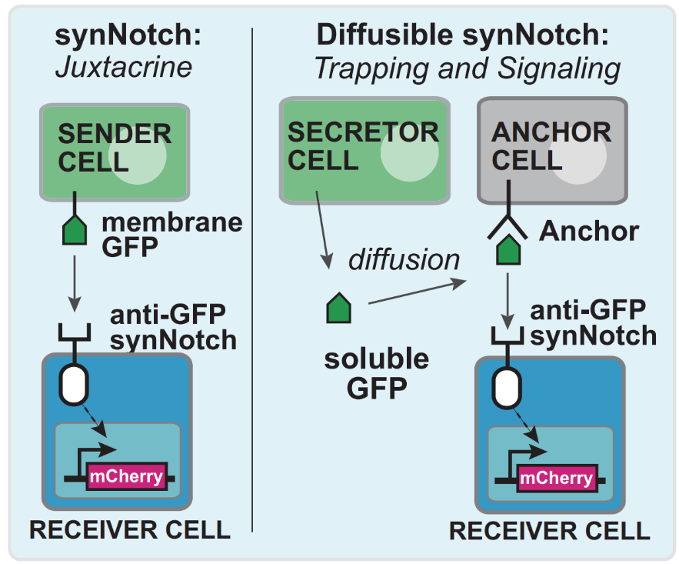

Question 1a) What is the role of anchor cells in morphological circuits that use soluble synthetic morphogens? (Hint: think about the mode of activation of the SynNotch receptor)

Question 1b) In the “diffusible synNotch” system described above, which component(s) would you change to obtain a positive-feedback circuit system?
Question 2) In the lecture you were also introduced to a circuit that enabled spatial organization of cells into three defined layers (see image below).

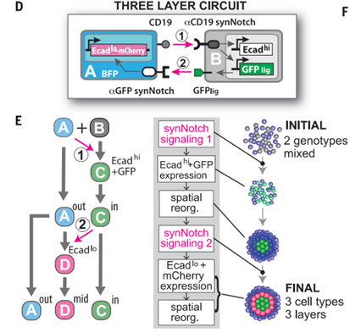

What would happen if the circuit lacked Cadherin (Ecad) in both A and B cells (see figure below)? Like the schematic figure above, explain which genes are expressed when and in which order, and how the final structure will look (how many cell types & layers are there?)

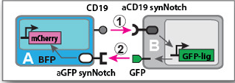

SOLUTIONS
Question 1a) Soluble ligands do not activate synNotch because exposure of the cleavage site requires the mechanical force of a membrane-tethered ligand.
By tethering the diffusible ligand to a complementary engineered anchor cell, the soluble ligand is converted to a quasi-membrane tethered ligand capable of activating synNotch.

Question 1b) To obtain a positive-feedback circuit system one can replace the mCherry in the receiver cell with gene encoding soluble GFP.
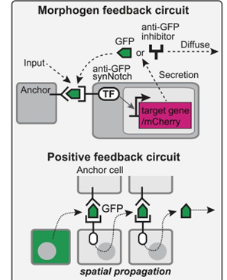

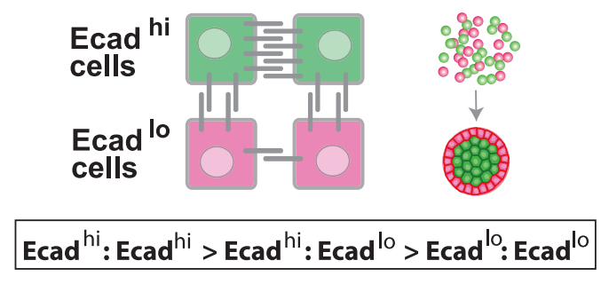
Question 2)
Note: Cadherin mediates cell-adhesion , see lecture slides p24. cells expressing Ecad_hi spatially organize with other cells expressing Ecad_hi. Same logic applies for cells expressing Ecad_lo.

In the case of no cadherin in both Cell A and Cell B, the first signaling induces GFPlig in B-type cells without cell sorting, and then the second signaling activated mCherry in A-type cells. This results in an random mixture of blue, green and red “cell types” lacking spatial organization

